Service Description

Easymail

INDEX

1 GENERAL Description 3
2 FUNCTIONAL Description 3
2.1 Detailed Product Description 4
3 SERVICE PROVISIONING 4
3.1 Implementation Method (Service Initial Set-Up) 4
3.2 Service Termination 4
4 SERVICE LEVEL AGREEMENT 5
4.1 Object 5
4.3 Methodologies 5
4.4 Information and advice 5
4.5 Exclusions 5
4.6 Responsability 6
4.7 Security on the infrastructure 7
4.8 Customer Service Center 7
4.9 Incident levels 7
ANNEX – Specific Description of Personal Data Processing 9

GENERAL Description
When an e-mail message is sent to a domain other than the user's, SMTP (Simple Mail Transport Protocol) ensures that the message is transferred to the recipient's domain.
Despite today’s upcoming transition to cloud services, many customers still put value on their own local email server infrastructure for valid reasons like privacy, specific features or legal regulations.
However, customers managing their own local email server may encounter following problems:
- Bursts or DDoS attacks on port 25 (SMTP) open to the internet.
- High investment in email security appliances or software.
- Time-consuming customization and maintenance of email architecture.
- Need of expertise to troubleshoot and analyze email traffic related problems.
- Email server uses often only one IP address for incoming and outgoing mail traffic – risk that outgoing IP address will be listed on RBLs.
Easymail will help solving these problems, in collaboration with the customer’s local email server infrastructure.
Easymail is POST mail transfer agent which enables companies to use a separate domain and mail server for mass e-mail delivery. This enables companies to send marketing messages to thousands of recipients without the company's domain appearing on the spam blacklist.
The main importance of Easymail lies in its ability to send messages to the intended recipient on behalf of a third party. No other protocol is responsible for managing outgoing messages, which is why SMTP is configured on thousands of mail servers.

FUNCTIONAL Description
Easymail works like an email gateway for outgoing mail traffic and allows registered customers to hide and protect their local email server from the Internet.
Easymail offers following improvements to customer’s local MTA (Mail Transfer Agent) :
- high value email protection layer including AVAS scanning and partial Content Filtering.
- at least 1 active and supervised outgoing IP addresses from different IP pools, ensuring that customer’s outgoing valid email traffic will arrive at the destination.
- customer’s MTA may be configured and run as a basic email service, focused on end-user specific requirements.
- customer may rely on POST email experts for troubleshooting and email traffic analyze.
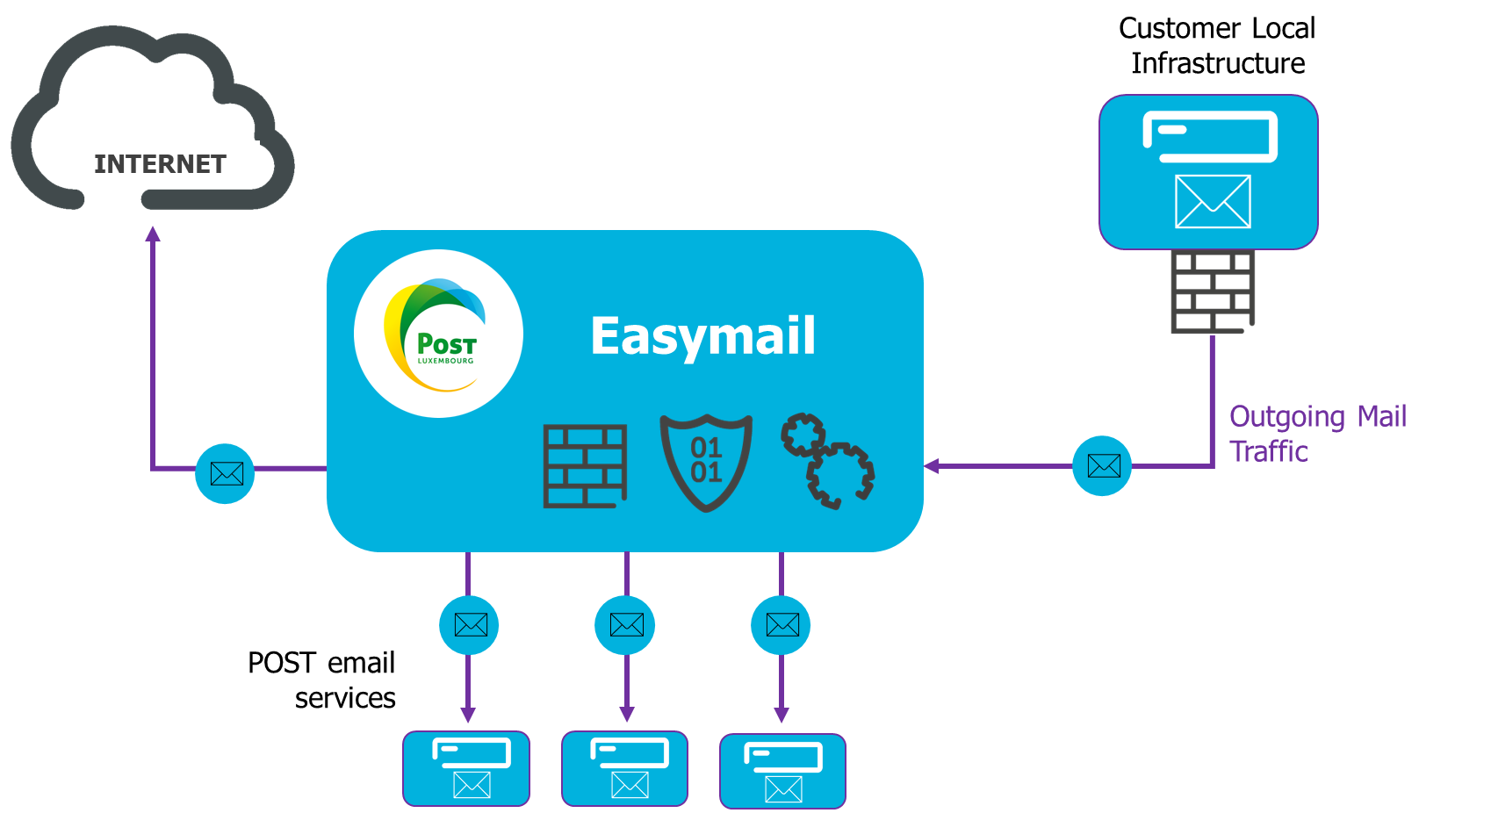

Detailed Product Description
Easymail is a secure mail relay dedicated exclusively to POST Telecom business customers.
Customers can send unlimited numbers of email for free.

SERVICE PROVISIONING

Implementation Method (Service Initial Set-Up)
POST :
- Register Customer Domain Name
- A link is generated
  - Adding customer’s relay mailhost (incoming)
  - Adding customer’s domain names (incoming)
  - Adding customer’s outgoing IP addresses (SMTP route)
Customer:
  - Including POST SPF record into customer’s Network

Estimated setup time :
- POST : 1 hour
- Customer : 1 hour

Estimated deployment time: 1 day (after having received an order and depending on customer reactivity)

Service Termination
Easymail is reserved for POST Telecom professional customers who have subscribed to other services. Termination of all POST services results in termination to Easymail. When the professional customer has canceled their last POST Telecom service, the Easymail service will be deactivated for successive months. Notice will be sent to the professional customer before the desactivation.
No early termination fees relating to Easymail will be requested.

- POST Technologies:
  - Remove customer’s relay mailhost
  - Remove customer’s domain names
  - Remove customer’s outgoing IP addresses
- Customer:
  - Remove POST SPF record from customer’s Network

SERVICE LEVEL AGREEMENT

Object
The purpose of this Service Level Agreement (SLA) document is to define the Service Quality available for the product and the commitments to deliver such Service Quality.
The SLA defines the key performance indicators, the target values set to be achieved, the measurement method and the reporting options.
POST Telecom offers several types of SLA whose specifications are described in this document.
The type of SLA applied for the delivery of a Service is specified in the Service Contract.
  - Validity and review process
The Customer may ask to modify the SLA. This might be possible in a common agreement beween both parties and validated by the signature of a new Service Contract.

Methodologies
Services are performed according to methods used by POST Telecom. These methods are processes, techniques, know-how, resources or organizations implemented by POST Telecom.
The organisation and delivery processes are based on ITIL best practices and recommendations. They also correspond to quality and security requirements of Standard like ISO 27001.

Information and advice
During the SLA execution, POST Telecom is committed to providing all information and advises to Customer to guarantee the level of expected Services.
In return, the Customer undertakes steps to cooperate in good faith to complete qualification requirements at the level of feedback information.

Exclusions
POST Telecom responsibility cannot be engaged, and the SLA does not apply in the following cases:

- Failure of Goods, Solutions and Services not listed in the Service Contract and in the Service Description
- Failure of Goods, Solutions and Services not provided and not managed by POST Telecom
- Failure caused by a breach of an obligation from the Customer as defined in the Service Contract and the Service description.
- Reasonably accurate information is not shared with Post Telecom Service Desk when reporting or handling an Incident.
- Malfunctions are caused by materials, physical elements, equipment and /or Software installed by the Customer.
- Configuration changes on the System set-up as agreed in the Service Contract are performed by the Customer without POST Telecom approval.
- The Customer prevent POST Telecom from performing maintenance tasks or necessary service updates.
- Malfunction caused by Systems not supported by POST Telecom
Identifying, examining and rectifying any of the following faults may result in extra charges from POST Telecom to the Customer:
- Failure are caused by serious negligence of the Customer or any other person having access to the Services delivered by POST Telecom
- Failure are due to deliberate damages by the Customer on the Service delivered by POST Telecom
With that being said, POST Telecom aims to be a helpful and accommodating partner at all times and will do its upmost to assist as much as possible the Customer.

Responsability

POST Telecom responsability
POST Telecom will provide and maintains the System used by the Customer as agreed in the Service Contract.
In addition, POST Telecom will:
- Respond to support requests within the timescales listed in this document.
- Take actions to identify and resolve issues within the timescales defined in this document.
- Maintain regular communication with the Customer.

Customer responsability
The Customer will use the System provided by POST Telecom as agreed in the Service Contract.
In addition, the Customer will:
Notify POST Telecom with issues or malfunctions as soon as possible.
Provide POST Telecom with all necessary access to the System(s) for the purposes of maintenance, updates and fault prevention.
Maintain regular communication with POST Telecom
Be available and will, if necessary, collaborate in the incident resolution, particularly with Priority P1. He will confirm the resolution once the service is back to normal conditions.

Security on the infrastructure
POST Telecom has implemented an effective control and security mechanisms to prevent any unauthorized physical access to Operational Systems, applications and / or POST Telecom Equipment. These mechanisms allow POST Telecom to ensure that access to System(s) and Customer data is limited to authorized users only and that all Customer’s confidential information is protected against misuse.
POST Telecom security policies are based on ISO 27001 code of practice for information security controls.

Customer Service Center
The Customer Service Center is your single point of contact 24h/24h 7d/7 for support requests.
An operational document with information’s of contacts and modalities is provided at the beginning of the service support.
The Customer Service Center can be contacted by phone (80024000), mail (commercial.telecom@post.lu).
The table below shows the “Response Time” applicable to the different communication channels. The requests (Incidents and Service Requests) will be handled during the Service Window of the respective subscribed service:

Communication Channel | Qualification (Response Time) by the  Customer Service Center
Phone | < 15 minutes
email | < 30 minutes
Customer Portal | < 15 minutes
Figure 1: Channels & Response Times

Incident levels
Based on its Incident Management process, POST Telecom Customer Service Center logs and classifies any Incident with a corresponding Priority, based on the impact.

Incident Priority | Impact | Explanation
P1 | Complete failure of the service | Customer production or the usage of the solution/product is stopped or so severely impacted that the Customer is not able to reasonably continue working on daily operations. No acceptable workaround is available
P2 | Serious degradation of the service.  Daily operations possible, but seriously affected. | The service is not stopped, but does not run according to specifications and one of the following conditions holds:  - Important features are unavailable with no acceptable workaround.  - Sporadically (intermittently) but not complete failure of the service (solution/product).  - Performance or Availability of the System is affected. There is a serious impact on Customer productivity and/or Service level.
P3 | Moderate impact of the service or on daily operations. | - Important feature/functionality are unavailable, but a workaround is available, or  - Less significant feature is unavailable with no reasonable workaround, or  - An issue occurred but the impact on Customer's daily operations is limited.
P4 | No impact on the service or on daily operations. | No impact on the Service or on Customer's daily operations.
Figure 2: Incident Priority

 | SLA Standard
Service Window | 7am – 7pm Monday to Friday (business days)
Priority 1 to Priority 4  Time To Repair or Intervention Time  Update Cycle | Best effort  n.a
Figure 3: Service level

ANNEX – Specific Description of Personal Data Processing
The Personal Data Processing in the context of the execution of this contract is carried out in accordance with:
- The General Conditions;
- The Personal Data Notice for Professional Customers – General description available on https://www.post.lu/en/particuliers/conditions-des-offres; and
- This specific description of the Processing of Personal Data.
For the purposes of this Appendix, the capitalized words have the meaning set out in the "Personal Data Notice for Professional Clients".
This Specific Description sets out the Instructions that the Customer, as Controller, submits to POST Telecom, as Processor, concerning the Personal Data Processing that POST Telecom (and, where applicable, the Sub- Subsequent Processors) must perform in connection with the execution of the Services subscribed by the Customer.
- The Data Processor Processes the Personal Data on behalf of the Data Controller in order to provide the following Services: the Secured email relay service described in this document.
- The Data Processor’s contact person or DPO is:
POST Luxembourg, DPO, 38 place de la Gare, L-1616 Luxembourg | E-mail: privacy@post.lu
- The Data Processing activities carried out by the Data Processor are the following:
Storage, consultation, erasure or destruction
- The purpose(s) of the Processing is(are):
The Data Processor may process the data in accordance with the objectives set out in this Amendment and, in general:
- to provide his services to the Processing Manager,
- for the purpose of detecting, preventing and mitigating fraud,
- to offer, maintain and improve services.

- The Data or categories of Processed Data:
standard identification data, electronic identification data, authentication data
- The categories of Data Subjects are:
Data subjects are the individuals whose data is processed by the Data Processor and may include End Users, Customers or Employees of the Data Controller.
- The Processing is geographically localized: Luxembourg.
- The Processed Data is retained for a period of: 6 Months
- The categories of sub-processors involved in the Data Processing are:
In the Frame of POST Telecom activities and within the limits of the purposes described above, Data are supplied or available by:
- Providers of IT and Telecommunication services (telecom installation, troubleshooting);
- Providers of platform and equipment (including support and maintenance);
- Providers of hosting solutions and services for cloud (POST and EBRC);
- Providers of billing services.

- Special instructions (if any): Not Applicable

The usage of the Portal must be explicitly requested and validated by POST Telecom

